SW Mid Term

Anwar Ul Haq
Id: 00019868

Tomcat Setup
Installation
- Download Tomcat binary from http://tomcat.apache.org/download-55.cgi. For windows download the zip file.
- Unzip it in any folder you like.
- After unzip go to the unzipped folder under /bin directory.
- Run startup.bat (before run please make sure your JAVA_HOME is set).
- CATALINA_HOME is going to be setup your root directory..
- Open browser and type http://localhost:8080, If you see the Apache page it means you have set it up correctly..
- On the left side of the page you see Status, Manager, Documentations links and etc..

Setup User
To access manager and status pages you need authentication to use it. You can go to $CATALINA_HOME/conf folder and open tomcat-users.xml. You can add user by adding this <user username='anwahaq' password='secret' roles='standard,manager'/>.
To know more about roles please see the tomcat documentation here

Deploy an application
There are many ways to deploy an application you may go and look here http://tomcat.apache.org/tomcat-5.5-doc/manager-howto.html but the most easiest I found is to open a deployment manager by typing http://localhost:8080/ into your browser and click Tomcat Manager link on the left side of the page or http://localhost:8080/manager/html. In this page you can see the status of already deployed applications and you can start/stop any application. On this page there is an option ?WAR file to deploy? to select a war file and deploy.

SW410 Mid Term
Download the components
Component | Version
Eclipse IDE | 2.1.2
Java SDK 1.4.1 | 1.4.1 or greater
Tomcat | 5.5
Eclipse Tomcat launcher plug-in by Sysdeo | Sysdeo Tomcat plug-in 2.2.1
Download each of the components that you require. The sites where the files are available at the time this article was published are listed below in the Resources section.
Eclipse IDE: The Eclipse IDE is used as the development environment for your JSP pages and Java files. Eclipse is an easy IDE to use, with many features that make for quick and painless Java programming and debugging. With the addition of the Tomcat plug-in, this IDE becomes a great tool for managing entire Web projects, including HTML and JSP pages, icons, and servlets.
Java SDK: An SDK is required for the Tomcat Eclipse plug-in to function correctly. It does not necessarily have to be the Sun SDK, but it has to be an SDK, (you cannot use just a JRE as it will not work). There must be a Java compiler present in the SDK in order for Tomcat to function with Eclipse. .
Tomcat: Tomcat is needed to drive your JSP pages. The Tomcat engine is a very good servlet engine that is free and easy to install.
Eclipse Tomcat Launcher plug-in by Sysdeo: This is just one of the many Eclipse plug-ins for Jakarta Tomcat. This is a good plug-in that saved me lots of time and integrated my Web projects with my Java code that I would usually use Eclipse to program.
Installation
Once you have downloaded what you need, the next step is to unzip each file. Unzip them and put them all in the same directory to keep track of what you are unzipping. Copy the Tomcat plug-in into your Eclipse/plug-ins directory.
Once all of the files are unzipped, copy the Tomcat plug-in directory into the plug-ins directory in your Eclipse directory. The name of the directory that I unzipped from the Sysdeo ZIP file was com.sysdeo.eclipse.tomcat_2.2.1. I copied this entire directory into my Eclipse/plug-ins directory.
Configuration
Begin by starting Eclipse. You will have to configure several options from the workbench preferences pages. Open the preferences dialog by selecting Window > Preferences, as shown in below.
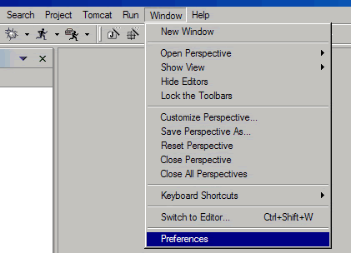
Select the Java option from the left-hand tree view. Expand the Java element and select Installed JRE's, as shown below.
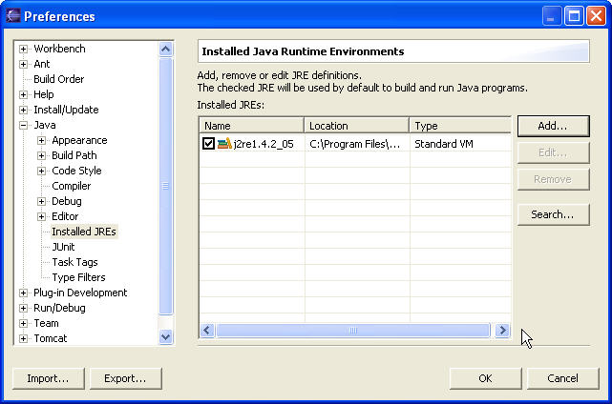
Click "Add" and navigate to the JRE directory of the SDK (C:\j2sdk1.4.2_05\jre) .Input JRE name and click "OK".
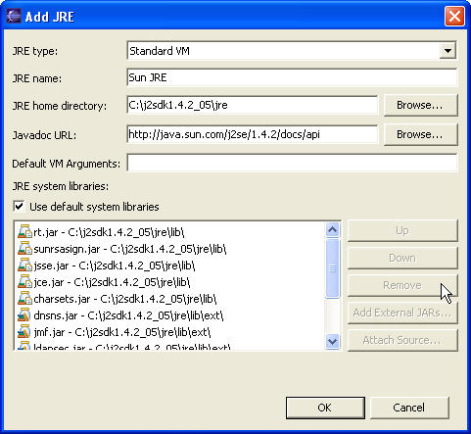
Check the check box beside the JRE that you just added from the SDK you installed, as shown below. This sets this JRE as the default JRE to be used by Eclipse. You must do this for the Tomcat plugin to work. The Tomcat plugin requires that an SDK be the default JRE selected in these Eclipse preferences.
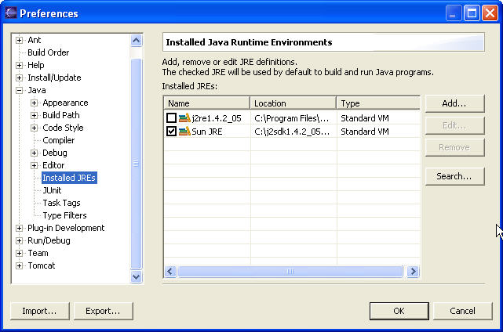
Set the Tomcat plugin preferences. First, select Tomcat from the left tree menu, then check Version 5.x, then click Browse to select Tomcat home (C:\jakarta-tomcat-5.0.28).
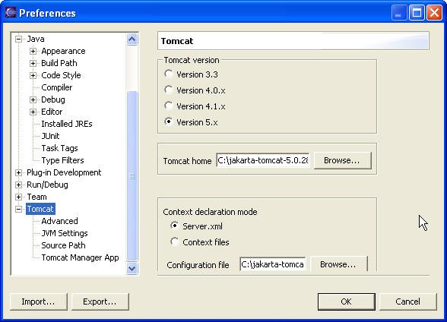
Select JVM Settings from the left tree menu, add tools.jar to Classpath.Then click OK.
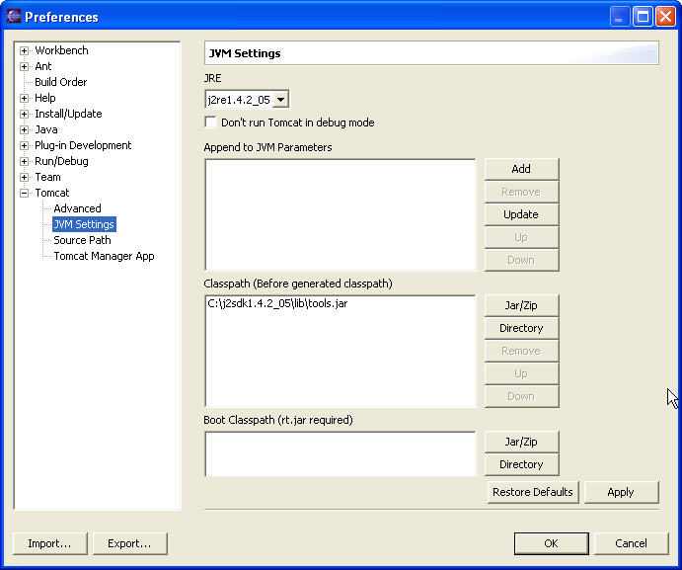

SW410 Mid Term
Create Project
Select File > New > Project and select a new entry Tomcat Project , then press Next
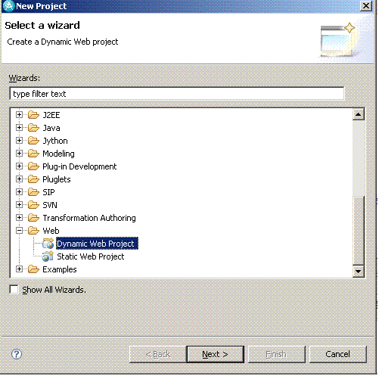
Give project a name such as SW410MidTerm and press Next.
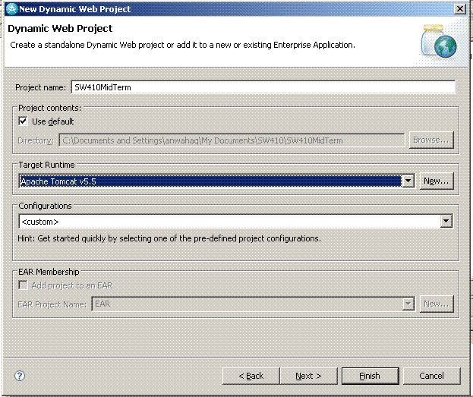
Define context root Press "Finish"
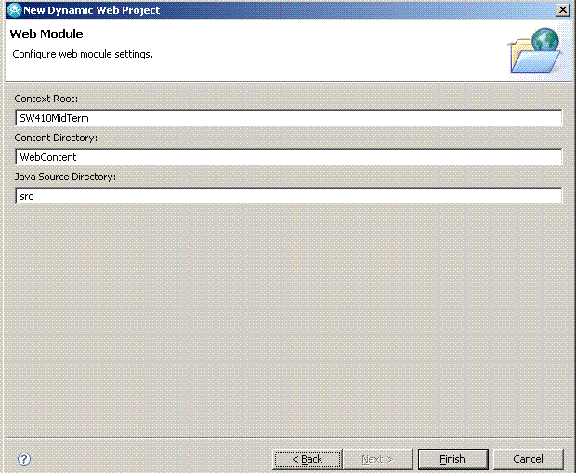
In Project Explorer you should see like this (suppose we created SWMidTerm project)
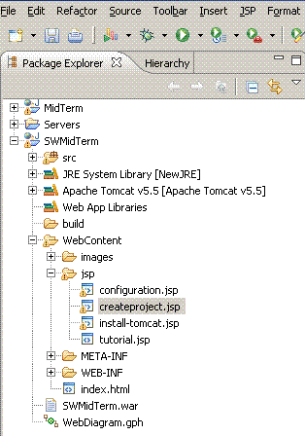
Adding a Servlet to the project. Right click src folder. Select New>Servlet>
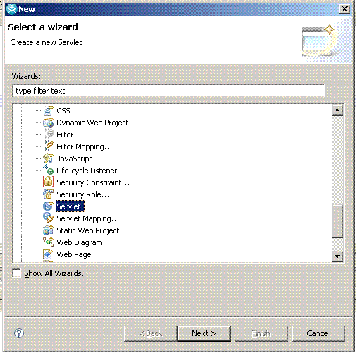
Give package and class name and press Finish.
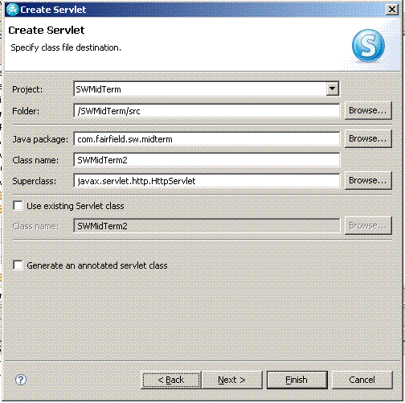
To execute a servlet,
first write some html in the doGet() method so that we can see in the browser that servlet is running.
Second we will start Tomcat server. To start server in the eclipse go to Windows>Views>Server view.
You should see Tomcat server in the server view.
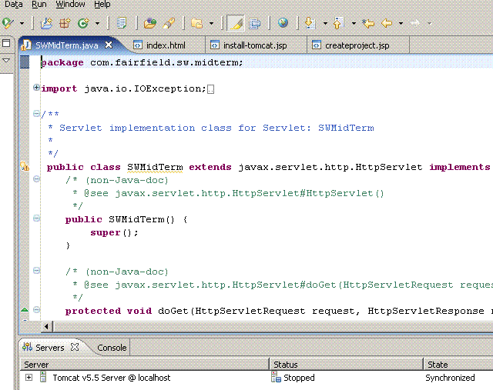
Right click on the Tomcat Server, Click "Add Remove Projects". Add SWMidTerm Project and press Finish.
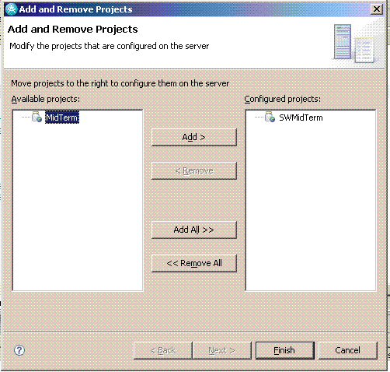
Right click on the Tomcat Server, Click "Start". Server will be started on port 8080. In the browser type http://localhost:8080/SWMidTerm/midterm, You will see servlet running. (midterm is the url mapping defined in the web.xml)
